Using Drones for Medical Delivery in Bristol

Celal Konuklu

# ***Campaign Overview***

Being the 10th most populated city in the UK, Bristol is experiencing notable growth, both in terms of its population and infrastructure. This expansion has given rise to a considerable issue - escalating traffic congestions on key roads, causing disruptions, particularly for emergency vehicles. Hence, a medical delivery drone is proposed which will carry vital drugs, blood samples and equipment between 2 of the most used hospitals in Bristol, namely Bristol Royal Infirmary (BRI) and Southmead Hospital (SH). The central location of BRI is a key factor driving the campaign, since it makes the hospital a focal point for medical services, but the high traffic density around it poses challenges for the medical deliveries. Using a medical delivery drone aims to mitigate these potential disruptions, ensuring the rapid and efficient transport of critical medical resources. While reducing the delivery times, this scheme will also aim to help reducing the carbon footprint, supporting the environmental sustainability efforts in healthcare. While the proposal holds promise, operating in an urban environment introduces complex challenges such as flight restrictions, ethical considerations and obstacle avoidance, which are further detailed in this report.

One of the notable advantages of using drones as means of medical delivery was proven in the Democratic Republic of Congo. While fighting with the Ebola outbreak, medical delivery drones were used to carry yellow fever vaccines to 40 different health facilities as quick as possible [1], which substantially reduced the pressure on the health services during the tough times.

Furthermore, a National Health Service (NHS) trust, named Northumbria Healthcare trialled a similar scheme, transporting medication, blood samples and chemotherapy drugs between hospitals using 70mph drones, which can carry up to 3kg of payload [2]. Although the trials were successful, the airspace closure required by these trials was significant, which affected two currently active airstrips for almost 5 months [3]. Therefore, a detailed path planning, and simulation is necessary prior to the trials in order to minimise these adverse effects.

## Campaign Site

Bristol is located in southwest England, with an average annual temperature of 12oC, a low of -3oC in January, and a high of 26oC in July [4]. These were evaluated using the data from the past 5 years, measured by the Filton Weather Station (located 2km away from SH). Although the average annual wind speed is 18.4km/h (5.1m/s), the strongest winds average 34.1km/h (9.5m/s) between October and March, peaking at approximately 37km/h (10.2m/s) in January [5].

The straight-line distance between hospitals is just above 4km, which takes around 15 minutes to drive without significant traffic (Figure 1). However, this trip can be done in only 5 minutes with a drone that is capable of achieving only 50km/h (13.9m/s) on a straight line. In reality, the drone will not exactly follow a straight line in order to satisfy regulations and to avoid obstacles such as tall buildings, power lines and prevent going over crowded areas. Path planning algorithms will be used to define the most suitable and efficient route for the drone, and these will be further discussed in this report.

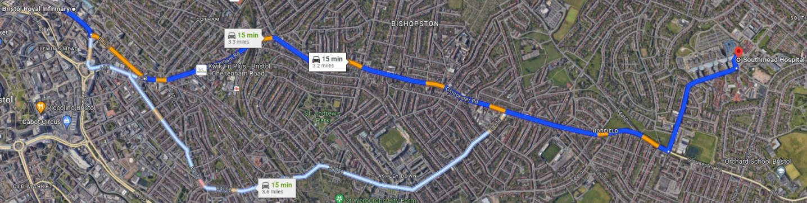

**4.22km**

**N**

Figure : Map Illustrating Distance between the hospitals

# ***Platform and Sensor Selection***

## **Requirements**

In order to select the most suitable drone for the campaign, requirements need to be defined. The *minimum* requirements and their rationales can be visualised in Table 1, which considers environmental, performance, and safety requirements.

Table : Platform and Sensor Requirements

|  |  |  |
| --- | --- | --- |
| *ID\** | *Requirement* | *Rationale* |
| E1 | The drone **shall** operate within the temperature range between -3oC to 26oC. | Evaluated from the past temperatures within 5th to 95th percentile in the past 5 years of weather data of Bristol [4]. |
| E2 | The drone **shall** have a wind resistance of 34.1km/h. | Evaluated from the past average wind speeds at the 90th percentile band in the past 8 years in Bristol [5]. |
| E3 | The drone and its components **shall** be waterproof. | It rains at least once every 3 days on average in Bristol [5] |
| P1 | The drone **shall** carry 2kg of payload (excluding container) between hospitals with 90% charged batteries. | The previous UK trial [2] is taken as a reference, scaling for the shorter flight distances for this campaign, and 90% battery is used as safety factor. |
| P2 | The drone **shall** take-off and land vertically (VTOL). | Easy infrastructure integration as both hospitals have helipads, on which helicopters currently operate. |
| P3 | The drone **shall** have a transmission range of 9km. | Evaluated as twice the distance between hospitals, to ensure reliable communication between the drone and ground station in case of significant diversion. |
| P4 | The drone **shall** have a battery life of 30 minutes with the maximum payload. | Conservative evaluation considering extreme conditions of diversion and extreme weather. |
| P5 | The drone **shall** autonomously avoid obstacles in real-time. | Due to operation in an urban area with many buildings, crowded areas and birds. |
| P6 | The drone **shall** achieve a ground speed of 50km/h (13.9m/s) with maximum payload. | This provides a delivery time of 7.5 minutes (half the time with a car) for a total flight distance of 6.3km (+50% of the straight-line distance, as a margin for obstacle avoidance and velocity variation). |
| P7 | The drone **shall** contain a camera that works under specified temperature range (E1), and it **shall** be waterproof. | To satisfy BVLOS regulations, and to have an improved reliability for drone status control. |
| P8 | The camera **may** provide clear vision at dim conditions. | Daylight ends at 16:00 in December, which *may* require operation at relatively dark conditions. |
| P9 | Charging time of less than 60 minutes ($±$ 10%) is **preferable** | This would improve the operational readiness of the drone. |
| S1 | There **shall** be means of monitoring drone health and status. | To provide real time diagnostics, which ensures safe and reliable operations. |
| S2 | The drone **shall** include multiple redundancies in key parts. | In order to improve the reliability of the drone. |

* E#: Environmental, P#: Performance, S#: Safety

## **Platform Selection**

The platform which satisfies all of the requirements defined above is “DJI Matrice 300 RTK” quadcopter [6], with the additional “Matrice 300 Drone Delivery Box” [7], which can be visualised in Figure 2. The main reason of this choice was the reliable reputation of DJI (the company), and the drone’s alignment with the requirements of the campaign, as the key specifications show in Table 2. In addition to the key specifications, the appealing features of this drone (which are also necessary in satisfying the requirements) include:

* Ingress Protection Rating of **IP45**, meaning that it is protected against low pressure jets of water (i.e., **highly reliable even in heavy rain**) – E3.
* **VTOL** and **quick manoeuvring** (as it is a quadcopter), vital for urban operations – P2.
* “**6 Directional Sensing and Positioning System**” that offers a **maximum detection range of up to 40m**, maximising obstacle avoidance capability, which enhances flight safety and drone stability – P5.
* **1080p triple-channel video** with **live mission recording** capability, providing a more immersive control considering the operations are BVLOS – P7. This can also extend the drone’s use to reach incident locations which require emergency personnel, to give a better understanding of the situation.
* **Auxiliary lights** on the top and bottom of the drone, enabling operation at dim conditions – P8.
* Incorporated **Health Management System**, which simplifies the health monitoring of the drone – S1.
* Contains critical **sensor redundancies** which maximises flight safety and reliability – S2. These include (but not limited to):

|  |  |
| --- | --- |
| * Dual Inertial Measurement Units | * Dual Barometers |
| * Dual RTK Antennas + GNSS Module | * Dual Compasses |

*Note: These are further elaborated on in Section 2.3.*

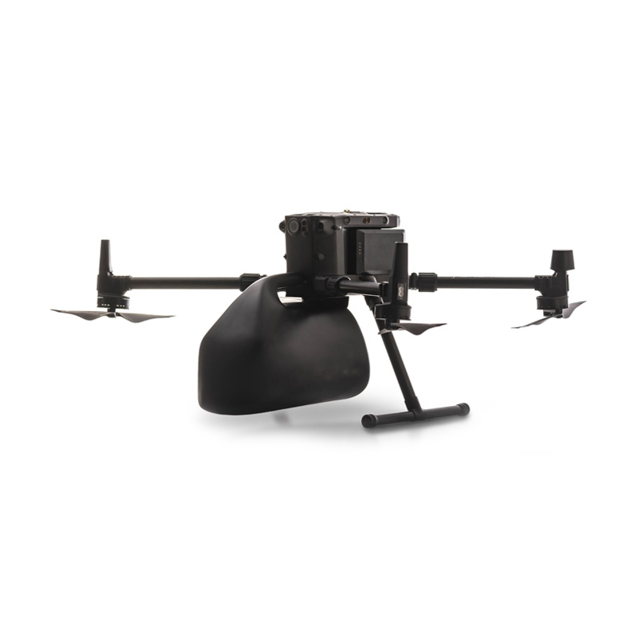

**Delivery Box**

Figure : DJI Matrice 300 RTK, with delivery box

Table : Key specifications of the drone [6]

|  |  |
| --- | --- |
| Drone Dimensions | Folded - 43×42×43 cm , Unfolded - 81×67×43 cm |
| Operating Temperature Range – E1 | -20°C to 50°C |
| Maximum Wind Resistance – E2 | 43.2km/h |
| Maximum Payload (without the box) – P1 | 2.7kg |
| Box Mass & Dimensions | 0.7kg, 26×21×31 cm |
| Maximum Take-off Weight (MTOW) | 9kg |
| Transmission Range – P3 | Up to 15km (with dual transmission link) |
| Maximum Flight Time – P4 | 31 minutes (with maximum payload) |
| Maximum Speed – P6 | 61.2km/h – 82.8km/h (mode dependent) |
| Charging – P9 | 60 minutes to full charge (with 220V input) |
| Batteries | 2 x LiPo 12S, 5935mAh, 52.8V |

## **Sensors**

The relevant sensors included with the drone, which will be crucial in each mission are as follows:

* **Dual Global Navigation Satellite Systems (GNSS)** connection to GPS or Galileo to provide real-time position (latitude, longitude and altitude) of the drone. This system is supported with **Dual Inertial Measurement Unit**, which measures three-axis acceleration and angular velocity to calculate velocity, position, and attitude. These are further supported by **Dual Compass**, which shows the heading of the drone.
* **Dual RTK Antennas** to provide long range communication with the ground control stations. This is connected to an **extra-wide FPV camera** to provide a 145o FOV (field of view) live feed for the pilot to maintain situational awareness and providing redundancy in case all other sensors mentioned above fail.
* **Six pairs of vision sensors** to provide obstacle sensing in every possible direction.

Therefore, being a transport/delivery mission rather than reconnaissance, there is no need to purchase additional sensors as these are sufficient, and offer excellent redundancy.

# ***Team Requirements***

For the proposed campaign, the success and safety of the operations depend on a well-coordinated and multi-disciplinary team, which consists of:

* ***Campaign Lead (x1) -*** Responsible for overall project planning, execution, and coordination; and oversees all team members, resources, and timelines. The Campaign Lead is the primary contact for the project, facilitating communication within the team, with stakeholders, and with management. They also ensure compliance with regulations and safety standards.

*Qualifications & Skills:* Apart from possessing a recognised project management certification (i.e. PRINCE2 or APM), the campaign lead must have adequate engineering and medical background in order to adapt the campaign to changes when necessary. They must also be capable of leading a diverse team.

* ***Delivery Manager (x2) –*** Each hospital needs to be equipped with its dedicated Delivery Manager, a key team member responsible for ensuring the smooth and safe operation of the drone. They monitor and assess the drone’s performance during flight to ensure it behaves as expected, as well as making frequent battery checks. In the event of any malfunctions or deviations from expected behaviour of the drone, the Delivery Manager notifies the relevant *Remote* *Pilot* to take necessary action. There needs to be constant communication between both Delivery Managers for frequent updates about the delivery status.

*Qualifications & Skills:* The Delivery Managers must possess an operational authorisation and an Operator ID issued by the UKCAA and are willing to renew their ID every year. They must also be proficient in working with the drone interface and have good engineering technical background. Finally, exceptional communication skills are a necessity for seamless operation.

* ***Remote Pilot (x2) –*** There is also a Remote Pilot at each hospital, who are in close collaboration with their dedicated *Delivery Manager*.Remote Pilots are responsible for conducting pre- and post-flight checks (see Section 4), swapping and charging batteries, executing manual take-off and landing, and fly the drone manually if advised by the *Delivery Manager*. Remote Pilots also need to communicate with each other and other operational aerial vehicles in the area, such as helicopters to adjust and verify the automated path of the drone as necessary.

*Qualifications & Skills:* Remote pilots shall have a valid flyer ID, and a remote pilot certificate issued by the UKCAA. Background in meteorology can be beneficial.

* ***Technician (x1) –*** Ensures the functionality, maintenance, and operational readiness of the drone and its related equipment. Technician is responsible of performing routine maintenance on the drone, repairing drone equipment as fast as possible, and providing technical assistance to the *Delivery Managers* and *Drone Pilots* in case of drone malfunctions.

*Qualifications & Skills:* Technician must have received a certified training and practical experience in maintaining and operating drones. A background in electronics and engineering is also vital.

* ***Medical Professionals –*** Dedicated Medical Professionals at both hospitals are responsible of providing expertise on the safe transport of the medical supplies and checking the quality and status of delivered medicines. There are sufficient Medical Professionals in each hospital who are extremely capable of taking these responsibilities, hence there is no need to recruit more for this campaign.
* ***On-call Ambulance Crew:***Responsible for conducting emergency response in case of a drone accident. They ensure quick coordination with the local emergency services to provide immediate first aid to any individuals affected by such incidents. Similar to the *Medical Professionals*, hospitals are expected to provide the ambulance crew when required.

# Operations

As described in Section 1, the aim of each mission is to carry medical payload in between BRI and SH. This will be achieved through “semi-automated” flights, where the path of the drone will be planned and loaded to the drone prior to the mission, and it will fly via an autopilot system. However, this will constantly be monitored and adjusted manually as necessary to ensure safety and security of the operation above the urban city. Take-off and landing will also be conducted manually by the remote pilot.

Both hospitals have their own helipads, which the drone will ideally use for take-off and landing. Alternatively, if the helipads are not available to use for any reason at an emergency, the compact size of the drone enables operation from/to the rooftop of each hospital that has sufficient space. Figure 3shows the ideal and alternative take-off and landing locations for the drone at each hospital.

Alternative

Ideal (i.e. Helipads)

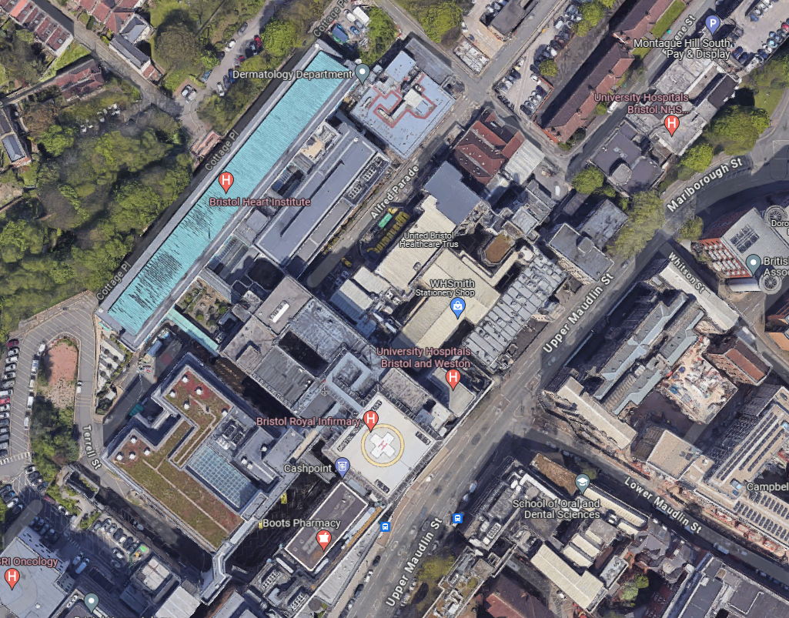

**BRI**

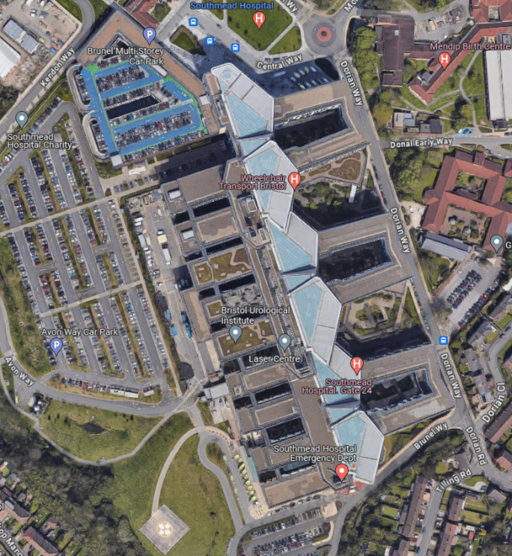

**SH**

Figure : Ideal and alternative take-off & landing locations

The medical payload can include blood test samples, life-saving drugs and even small medical equipment, making each mission very sensitive, requiring a pre-defined operational plan to ensure safe and efficient transport. The mission procedures before, during and after each flight are detailed in Section 4.1, whereas the drone waypoints and their justifications are detailed in Section 6.

## Mission Procedures

***Pre-Flight Procedures:***

* The medical payload is robustly placed in the delivery box to avoid damage. This should be done via the help of a medical professional.
* The delivery box is attached on the drone securely and properly fastened.
* Remote pilots review the current and forecasted weather conditions for the planned flight period. Factors such as wind speed, precipitation, and temperature are considered to ensure a safe flight.
* Remote pilots discuss and adjust the ideal flight plan (Section 6.2) if necessary to account for any airspace incursions and weather disruptions.
* Stable communication link between the delivery managers is ensured.
* Delivery managers setup the ground station and verify the accurate transmission of data from the UAV. This data includes the battery level, location data (GPS), status of the propellers and camera.
* Sufficient battery (with 10% margin) for the flight is verified.
* The ‘Health Management System’ (see Section 2.2) is checked to confirm that the drone is safe to fly.
* Remote pilot* performs final pre-flight checks to ensure that the aircraft responds appropriately to the commands.

***In-Flight Procedures:***

* The remote pilot* manually initiates the take-off procedure, ascending to the designated altitude, and verbally verifies with the delivery manager that all systems are functioning as expected.
* Drone flight is then switched to the automated (autopilot) mode to fly along the designated path.
* The delivery managers maintain continuous monitoring of the drone’s position, altitude, and its battery status throughout the flight.
* The remote pilot* consistently monitors the relevant airspace for any unexpected aerial activity which requires path adjustments.
* Consistent communication is ensured between the ground station, delivery managers and remote pilots. Any communication disruptions are promptly addressed.
* Delivery managers inform the remote pilot* in case of any unexpected drone behaviour, who will take manual control of the drone to adjust the path and/or carry out emergency landing at a safe location.
* The delivery manager at the receiving hospital informs the other delivery manager once their remote pilot has a vision of the drone.
* The remote pilot* initiates the landing procedure and ensures a safe and controlled descent.

***\**** *When the drone is BVLOS, both remote pilots are responsible for it, whereas if any remote pilot has a visual sight of the drone, the responsibility switches to them only for better control. However, both the delivery managers are responsible of the drone regardless of the visual sight during in-flight.*

***Post-Flight Procedures:***

* Once landed, the remote pilot conducts a post-flight inspection to check for any damages and/or abnormalities in the drone and its payload.
* Delivery manager retrieves the medical payload and verifies its condition with the help of medical professionals.
* Delivery manager ensures all data logs from the flight are saved and transmitted for analysis.
* The drone is securely stored, and the batteries are charged for future missions.
* Any incidents, deviations from the plan, or noteworthy observations during the flight are documented in the post-flight report which is then sent to the campaign lead for further evaluation.

# Regulatory and Ethical Compliance

## Drone Operational Authorisation

Operating in the United Kingdom, the main regulatory body for drone operations is the UK Civil Aviation Authority (UKCAA). UKCAA specifies different categories for the ways of using drones, and for different drone types. Although the proposed campaign and the selected drone satisfies the weight requirements set by the “Open Category A3” (MTOW between 2kg and 25kg), being a ‘Beyond Line of Visual Sight (BVLOS)’ operation that will fly over an urban area makes it impossible to begin the campaign without additional permissions from the authorities [8].

Since many operation elements will be outside the boundaries of the “Open Category”, the proposed campaign will most likely be in the “Specific Category”, which requires special operational authorisation. In order to obtain this, the Delivery Managers (see Section 3) must conduct a risk assessment of the proposed operation with the guidance of the Campaign Lead, who will be responsible of submitting this as a part of authorisation application. The application will be done online via the [UKCAA website](https://applications.caa.co.uk/CAAPortal/servlet/SmartForm.html?formCode=UAS) and the documentation submitted must be in line with the UK Reg. (EU) N.2019/947 (the UK UAS Implementing Regulation). It takes 28 working days for the UKCAA to confirm the application, hence this needs to be done as soon as possible to ensure early permission for further steps to be taken in the campaign.

The key detail to consider in this application is the fact that the drone is intended for BVLOS operation. UKCAA states that for this to be accepted, there are two requirements, one of which shall be satisfied:

1. ‘Detect and Avoid (DAA) Capability’ of the drone.
2. ‘Operational mitigation’, which reduces the likelihood of encountering another aircraft to an acceptable level, that may be achieved using a suitable method of ensuring such segregation [8].

Having a segregated airspace within an area where helicopters operate is extremely challenging and not advised by the UKCAA. Hence, the DAA capability requirement can be satisfied via using is “6 Directional Sensing and Positioning System” (described in Sections 2.2), that will autonomously adjust the behaviour of the drone and help informing the user during any airspace incursion, or unexpected events. There is also a high field of view camera (see Section 2.3) onboard which enhances this capability by providing live feed to the remote pilots, enabling a visual sight of the drone location and attitude.

## Insurance

In accordance with Regulation (EC) No 785/2004 of the European Parliament and Council, compliance mandates that the UAV, not categorised as a “model aircraft”, must “hold adequate levels of insurance in order to meet their liabilities in the event of an accident” [8]. This insurance needs to be acquired from the Civil Aviation Authority prior to the start of operations.

## Airspace Restrictions

The biggest restricted airspace in the operation region is the Bristol Aerodrome (Airport), but its boundary is significantly distant from the operation zone (7.3km away from BRI and 10.7km away from SH), making it an unlikely concern. The main permanent legal restriction to consider in the operation zone is HMP Bristol, a prison located between the hospitals that has a ‘Drone No Fly Zone’ restriction between the surface and 50m above ground [10].

Moreover, it is considered a suspicious activity to operate near helipads of the hospitals, which helicopters frequently operate. Therefore, a legal approval is required from both hospitals in order to use their helipads as a take-off and landing place.

There are also numerous schools, crowded areas (such as parks and a stadium) and power stations near or at the operation zone. Although there are no legal restrictions in the “Specific Category” for these places, it is advisable to avoid flying over them, and avoid them as the emergency landing locations. This is taken as an ethical concern rather than regulatory. Finally, the Remote Pilot must be up to date with certain aerial events such as hot air balloon events, firework displays, and drone light shows in order to temporarily adjust the designated path of the drone.

*-- Note: All these restrictions can be visualised in* [*dronesafetymap.com*](https://dronesafetymap.com/) *--*

Finally, drone flights 120m above terrain is restricted in the UK airspace. Fortunately, no building in Bristol is above 100m [9], so flights above 120m is not necessary for building avoidance.

## Ethical Considerations

It is vital to consider the ethics of this mission in order to have satisfactory market acceptance, and to prevent legal actions taken against the campaign. An example of an ethical concern is given in Section 5.3, but these considerations also include (but not limited to):

* ***Privacy:*** The cameras of the drone will capture images and data during their flights. Protecting the privacy of individuals in the flight path and ensuring that sensitive medical data is not compromised is essential. Hence, detailed encryption of drone data is necessary.
* ***Transparency:*** Open and transparent communication about the mission, its goals, and its safety measures is ethically necessary to build trust within the community.
* ***Noise Pollution:*** The noise generated by the drone may affect residents in the flight path, and the easiest way to avoid this is to fly the drone as high as possible (but below 120m)

# Path Planning

Although the straight-line distance is the shortest path between the hospitals, the drone will not necessarily travel along that line for numerous reasons. Operating in an urban area, the drone must have a detailed flight planning in order to:

* Safely clear obstacles such as high buildings, power lines, and birds.
* Satisfy with the current regulations set by the National Aviation Authority and avoid flying over unsafe zones described Section 5.3.
* Be able to carry out emergency landing at a safe location in case of unexpected events.
* Have the fastest and most efficient path while doing so.

These considerations are challenging to implement into the flight path of the drone manually, hence a more automated method of path generation is essential. This is where computational path planning algorithms become useful, and these will be used to define the initial path of the drone.

## Algorithm Selection

Every algorithm starts by defining the ‘obstacles’ which are the restricted airspaces, and zones that need to be avoided. The most efficient and useful way to represent the obstacles for the campaign is via line segments (i.e. lines to represent polygons). The next step is to choose which specific algorithm to use in order to determine the shortest path that avoids the pre-determined ‘obstacles’.

The first and simplest one to use is the ‘**Visibility Graph Method**’, which uses straight lines in between visible vertices of the defined polygon obstacles in order to evaluate the shortest path between the start and goal using **Dijkstra’s Algorithm**. Although this method yields the most optimal path in terms of distance, it leads to very close operation to the obstacles that may cause significant issues. Having a path away from the obstacles can provide a safety margin for the operation, for example in case of an adverse weather condition, where the drone might deviate from its dedicated path. Furthermore, operating away from obstacles enable a safe emergency landing procedure, or in the worst-case scenario, crash to an unpopulated region. Therefore ‘**Delaunay Triangulation**’ was considered, which systematically divides the defined space into triangles, and takes the mid-points of every boundary between neighbouring triangles as waypoints. These points are then joined using **Dijkstra’s Algorithm** to achieve the shortest path possible. The main advantage of this method is that it provides efficient computation, and paths that are away from obstacles. However, longer paths are obtained, which may be inefficient in terms of the drone battery use, and the time taken for the operation. Figure 1Figure 4 shows the differences between these two methods for better understanding.

Delaunay Path

Delaunay Triangulation

Visibility Graph Path

Figure : Delaunay vs. Visibility Graph

The final algorithm to consider was ‘**Rapidly Exploring Random Tree**’, which uses random points at each step in order to explore the algorithm space and come up with a *feasible* path. Although this method does not usually come up with an efficient path, it is especially useful if other algorithms fail to converge in complex spaces.

Overall, operating above an urban area requires safety to be taken as the main priority. Hence, the ‘Delaunay Triangulation’ method was found the most suitable algorithm for the proposed mission, and the waypoints found are depicted in more detail in Section 6.2. The resultant path will act as a good guidance and is subject to change in each operation due to temporary precautions, weather, time of the day and airspace incursions.

*-- Flights will ideally be at 100m above ground, enabling 2D algorithms to be sufficient for path planning --*

## Waypoints & Simulation

A folder was submitted along with this report, generating an optimal path between the hospitals using Delaunay Triangulation method, which is shown inFigure 5. Red polygons indicate the obstacles which include schools and universities, parks, a stadium, a prison, and an army reserve. The outer boundary (i.e. blue rectangle showing the region for optimal path search) was drawn by adding ~700m margin in north/south directions, and ~1100m margin was added in east/west directions from each hospital. This was done in order to allow for a greater operation space for the drone that may provide better routes. A larger margin (up to 15km) was possible since the transmission range of Matrice 300 RTK allows for it (see Section 2.2), but it was deemed unnecessary as the optimal route is unlikely to extend beyond the provided margins.

It can be noted that the path in Figure 5 (magenta line) features very sharp turns, which may cause problems such as spillage of medical payload if carrying liquids and may require the drone to stop and turn, increasing the time taken to transport the necessary payload such that it becomes inefficient. Therefore, ‘spline waypoints’ are enabled in the simulation to relieve this problem, which can be visualised in Figure 6. The simulation achieves a maximum velocity of 10m/s which yields a delivery time of around 10 minutes. Scaling this with the maximum velocity of the drone (17m/s) gives a delivery time of about 6 minutes which is 60% quicker than an average delivery with a car, with the additional benefit of ‘zero emissions’. The generated path and the simulations also show that the drone flies away from the restricted and dangerous regions, minimising the risks described in Section 7, and the operation is well within the transmission range (15km) which allows margins for diversions. Therefore, it is evident that each mission is likely to satisfy all the operational requirements, exploiting the need for a medical delivery drone.

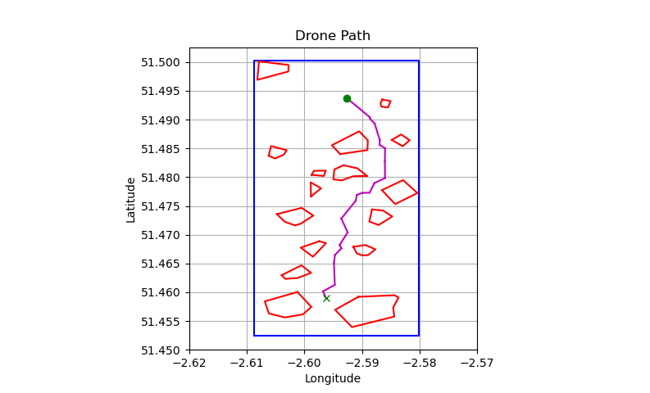

SH

BRI

Figure : Optimal Path using Delaunay Triangulation

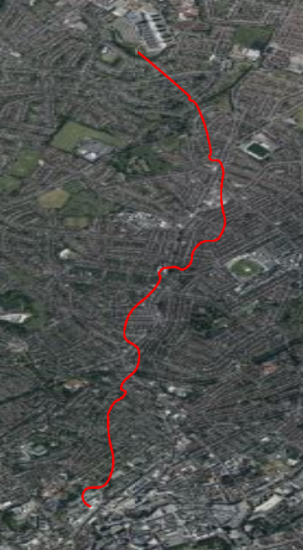

**BRI**

**SH**

Figure : Simulated path with 'spline waypoints'

Constraining the drone to have a constant altitude above terrain simplifies the obstacle considerations as operating the drone 100m above terrain avoids all buildings in Bristol. Since the regulatory limit is 120m (see Section 5), flying 20m below it also gives a safety margin to comply with the regulations. Figure 7 shows how the altitude of the drone varies above sea level during flight. Clearly, the drawback of this is the need for more intensive use of battery (in order to climb and descend throughout the flight) which can be inefficient. This problem can be overcome in the future by implementing 3D path planning algorithms which evaluate the best path by optimising for both the minimum battery usage, and the shortest time for delivery.



Figure : Sea Level Altitude Variation During Flight (SH to BRI)

Apart from flying through the ideal waypoints, the drone must also be capable of returning to nearest helipad in case of a communication loss, or must conduct emergency landing at a safe location if there is insufficient battery to return. This needs to be encoded into the drone before the operations begin, and various other cases of unexpected events must also be simulated prior to the campaign.

# Risk Assessment

Similar to any initiative, the medical delivery drone campaign is subject to a spectrum of potential risks that require thorough evaluation and strategic mitigation. Therefore, it is vital to identify and address factors that could impede the safe and effective execution of each medical delivery. Table 3 (on the next page) outlines key programmatic and health & safety risks, their potential impacts, likelihood, severity, and the robust mitigation strategies employed to ensure the success of the campaign.

The campaign, and each delivery is deemed successful if:

* The medical payload (blood samples, drugs, etc.) is carried safely in between hospitals without any damage.
* There is no damage to the drone, or loss of drone during each delivery mission.
* Each delivery takes notably less time than it would take with a road vehicle (car or ambulance).
* No individuals (both team members and uninvolved people) are harmed due to this means of delivery.

The occurrence (O) scale for both programmatic and health & safety (H&S) risks is the same, with 5 indicating that the likelihood is extremely high, and 1 indicating an extremely low likelihood. The severity (S) scale varies between the programmatic and health & safety risks. For programmatic risks, 5 indicates the failure of the whole campaign, and 1 indicates a slight setback in a single delivery, whereas for H&S, 5 indicates that the drone and all its medical content is unusable and/or there are severe injuries to *any* individual, and 1 indicates insignificant damage/injury to the drone, medical payload and individuals. A final risk score is determined by multiplying the occurrence and severity (Score = O $×$ S), with higher scores indicating a more considerable risk. This is also useful for the authorisation application described in Section 5.1, and the resulting risk assessment in Table 3 indicates that all the risks are at the ‘tolerable region’ according to CAP722A [11].

Note that in the event of an incident, establishing a robust documentation, reporting, and analysis process is crucial for learning from experiences, enhancing operations, and ensuring continuous improvement. Therefore, every incident during operations needs to be documented, and the campaign lead needs to be informed immediately, who will submit a formal incident report to UKCAA if found necessary.

*-- Risk Assessment Table is on the next page --*

|  |  |  |  |  |  |  |
| --- | --- | --- | --- | --- | --- | --- |
|  | Risk | Effect | S | O | Score | Mitigation(s) |
| Programmatic Risks | Sudden adverse weather disruption | Drone deviates from dedicated path, causing delays or cancellations in delivery | 2 | 2 | 4 | Employed remote pilot needs to be experienced, with a calm personality in order to manually fly and land drone safely.  Monitor weather forecasts regularly and establish predefined criteria for weather-related mission cancellations or delays. |
| UKCAA does not approve application | Delays in campaign start date | 4 | 2 | 8 | Campaign Lead must send the application as soon as possible to allow for setbacks and adjustments, in order to reach agreement with UKCAA. |
| Drone does not perform as well as in its documentation | Increased delivery times & operational costs | 3 | 3 | 9 | Carry out hardware tests and validation procedure prior to campaign.  Implement a rigorous maintenance schedule. |
| Breaches in data security or privacy concerns related to captured images and information | Legal actions taken against the campaign, causing financial and reputation loss | 5 | 2 | 10 | Enforce strong encryption protocols and comply with data protection regulations.  Communicate transparently about data handling practices. |
| Disruptions in the supply chain for drone components | Delays in maintenance or replacements | 3 | 4 | 12 | Diversify suppliers, maintain a buffer stock of critical components, and establish strong relationships with suppliers. |
| Both | Power loss on drone during flight | Unsuccessful delivery, loss of crucial medical items | 4 | 2 | 8 | Optimise battery usage and charging procedures. Monitor battery health regularly and replace any misbehaving batteries promptly. |
| Drone crashes to ground, posing hazard to uninvolved people | 5 | 2 | 10 | Carry out automatic emergency landing if drone starts to behave unexpectedly.  Ensure the flight path of the drone is away from restricted & dangerous regions so the drone falls on a safe place. |
| H&S Risks | Collisions with other aerial vehicles. | Significant damage and debris, posing hazards to people on the ground & in the aerial vehicle | 5 | 1 | 5 | Ensure “6D Sensing and Positioning System” of the drone works satisfactorily.  Regularly check drone safety maps and regulations to be aware of any sudden or planned aerial activities, and any restriction adjustments |
| Public interaction with the drone (e.g., trying to touch or capture it) | Loss of drone, damage to drone and stolen medical drugs | 4 | 2 | 8 | Have a suitable insurance for the drone (see Section 5.2).  Improve security of the drone delivery box (i.e. locks and location tags)  Carry out public awareness campaigns to minimise the risk of physical interaction. |
| Members of team getting ill before, or during the operations | Inability to perform operational tasks safely and efficiently. | 2 | 4 | 8 | Develop contingency plans by ensuring cross-training within the team. |
| Electromagnetic Interference (EMI) from electronic devices or power lines. | Interference with the communication systems and navigation, potentially leading to loss of control. | 4 | 1 | 4 | Conduct EMI assessments, establish no-fly zones near high-risk areas, and use shielded equipment. |
| Inadequate medical supply handling | Contamination of the medical supplies, posing significant danger to patients | 5 | 2 | 10 | Implement secure packaging protocols, train team members on proper handling, and conduct regular quality control checks. |

Table : Programmatic and H&S Risk Assessment

# Future Developments

Driven by the technological advancements and the constantly updating regulations, the future of medical delivery drone operations can provide numerous opportunities. There are many potential developments which could shape the trajectory of this campaign, enhancing efficiency, safety, and overall impact.

## Fully Automated Operations

Currently, the operations are defined as “semi-automated”, where the automated path is pre-defined for the drone (i.e., autopilot), but the take-off and landing procedures are carried out manually, and the flight of the drone is constantly monitored by the delivery manager for safety. However, similar to many other drone operations, fully automated operations would play a vital role in the evolution of this campaign. The potential of transporting medical resources without direct human interaction can provide reduced delivery times and expanded operational hours.

Automation will require integration of novel technologies such as artificial intelligence (AI) and machine learning in order to make real-time decisions and optimise the flight paths automatically. For example, AI algorithms can use real-time data on weather conditions, airspace incursions, and any events (either aerial or ground-based crowds) in the area in order to operate along the most efficient and safest path each time. Additionally, machine learning can enable drones to learn from various circumstances prior to the operations, and safely adapt to any unforeseen events while in use, which may also help reduce human error. The high quality and redundant sensors on Matrice 300 RTK such as the “6 Directional Sensing and Positioning System” (see Section 2) can improve the benefits of these technologies by providing reliable data.

While there are considerable benefits to it, using AI and machine learning will have many challenges, such as the need for high-quality training data, ethical considerations in decision-making algorithms, and the future regulations on using AI [12]. Furthermore, fully automated drone operations would bring difficulties especially in regulatory approval by UKCAA since there are no clear regulations about automated flights yet, but is forecasted to be included in the regulatory documents in the near future.

## Network Expansion

Another way to develop the campaign is to increase the number of hospitals (or healthcare facilities) reached by the drone, extending the medical deliveries to more remote regions around Bristol, and nearby towns. This can be achieved with a smaller scale method of Altitude Angel's proposal to establish a dedicated “superhighway for drones” [13]. Combining network expansion with automation can enhance the speed of healthcare accessibility to less urban locations, increase the availability of various medical drugs at more locations, and improve the trust of the community to the country’s healthcare. Similar to automation, expanding the network introduces challenges, mainly related to:

* *Infrastructure development*: Transponder zones along the paths of the drone may be required to locate the drone and communicate with it in case it needs to change path due to airspace incursions.
* *Regulatory approvals (UKCAA)*: More extensive risk analysis needs to be considered in order to gain approval. Regulatory body is likely to be stricter in this case, especially if automation is also considered.
* *Drone selection*: The operational requirements, hence the platform requirements will change for the campaign (especially due to the improved operation range). This will lead to a different drone selection, or even a new drone design to satisfy the mission requirements. Furthermore, multiple drones may be necessary due to the extended operations, increasing the initial investment to the campaign significantly.

Overall, commercial drone operations are relatively new, and un-proven concept of transportation. Therefore, it will be necessary to start from the most ‘basic’ way (as detailed throughout the report) and improve the operation as the technology and regulations mature.

References

|  |  |
| --- | --- |
| [1] | E. Snouffer, “Six places where drones are delivering medicines,” Nature, 2022. [Online]. Available: https://www.nature.com/articles/d41591-022-00053-9. |
| [2] | A. Dutton, “The 70mph drones taking hospital medical supplies to the skies,” Independent, 2023. [Online]. Available: https://www.independent.co.uk/news/health/nhs-drones-hospital-medical-supplies-b2281946.html. |
| [3] | “Northumberland NHS drone trial 'massive airspace grab',” BBC News, 2023. [Online]. Available: https://www.bbc.co.uk/news/uk-england-tyne-66742698. |
| [4] | “Horfield and Bristol Weather Station, Summary of Weather Data,” 2023. [Online]. Available: http://www.martynhicks.uk/weather/data.php. |
| [5] | “Climate and Average Weather Year Round in Bristol,” Weather Spark, 2023. [Online]. Available: https://weatherspark.com/y/39587/Average-Weather-in-Bristol-United-Kingdom-Year-Round. |
| [6] | “DJI Matrice 300 RTK,” DJI, 2023. [Online]. Available: https://enterprise.dji.com/matrice-300. |
| [7] | “DJI Matrice 300 Drone Delivery Box,” DJI, 2023. [Online]. Available: https://store.dji.bg/en/matrice-300-drone-delivery-box.html. |
| [8] | “Unmanned Aircraft System Operations in UK Airspace - Policy and Guidance,” UK Civil Aviation Authority, 2022. |
| [9] | “List of tallest buildings and structures in Bristol,” Wikipedia, [Online]. Available: https://en.wikipedia.org/wiki/List_of_tallest_buildings_and_structures_in_Bristol. [Accessed Nov 2023]. |
| [10] | “Drone Safety Map,” [Online]. Available: https://dronesafetymap.com. [Accessed Nov 2023]. |
| [11] | UKCAA, “CAP 722A, Second Edition,” Dec 2022. [Online]. Available: http://publicapps.caa.co.uk/docs/33/CAP722A_Edition_2.pdf. [Accessed Nov 2023]. |
| [12] | M. Schaake, “The route to AI regulation is fraught but it’s the only way to avoid harm,” Financial Times, Dec 2023. [Online]. Available: https://www.ft.com/content/99ff5c84-ece7-43bf-bed1-2edb30d4d6df. |
| [13] | “UK consortium reveal blueprint to build 165 mile drone ‘Superhighway’,” Altitude Angel, Mar 2022. [Online]. Available: https://www.altitudeangel.com/news/uk-consortium-reveal-blueprint-to-build-165-mile-drone-superhighway. |